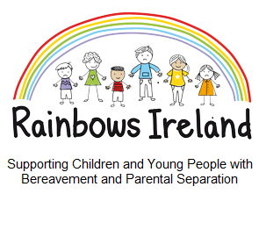
Expression of Interest Form (Bereavement loss)
Shannon Family Resource Centre.
(Official Enrolment Form will follow)

Child’s Name: _______________________________________________Age: ________
Rainbows Centre Name: Shannon Family Resource Centre _______________________
Applying Parent/Guardian name: _____________________________________________
Applying Parent/Guardian mobile number: _____________________________________
Applying Parent/Guardian email address: ______________________________________
Date of Expression of Interest: _______________________________________________

For Further Information:
The Rainbows Coordinator can be contacted with any questions you may have on:
_______________________087 1232489_________________________________
Please leave your contact details and the coordinator will get back to you. Please speak slowly when leaving your contact number.
(This is a Rainbows phone and is checked for calls regularly)

Expression of Interest Form should be returned to:
Cathal Dillon,
Shannon Family Resource Centre,
Rineanna View Community Building,
Rineanna View, Shannon, Co Clare.
V14 XV97 Or via email cathaldsfrc@gmail.com

